Recommended Setup for Local Machine

The following documentation provides a full tutorial on setting up your local machine with the recommended environments and methods. This documentation is part of the Onboarding Checklist for New CoM Members and can be followed entirely to setup and run the data science team components. Please note, this tutorial is completed on a MacBook, however, all executions will be the same for windows.

# 1. Install and Setup Git

In this tutorial, we will be using Git from the terminal (this is what most previous students have done). To check if Git is already installed on your device, open a terminal, and run the command ‘git version’. If it is installed, the current version of git should be printed to the terminal like below:

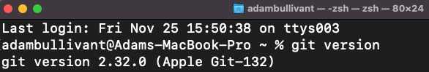

If Git is not installed, you can install it [here](https://git-scm.com/downloads). Once installed and instructions are followed, try the above command again.

# 2. Clone MOP-Code Repository

Now that Git has been installed, we can clone the repo to our local machine. First, we must open the repo [here](https://github.com/Chameleon-company/MOP-Code). Once opened, click the green ‘<> Code’ button as follows:

Now, copy the link to your clipboard. If you don’t have SSH setup, just click ‘HTTPS’ and copy that link provided.

Next, we must decide where we would like the repository to be located on our local machine. For this tutorial, I will be creating a ‘GitHub’ folder inside my ‘Documents’ and storing it there, however, you can store it wherever you want:

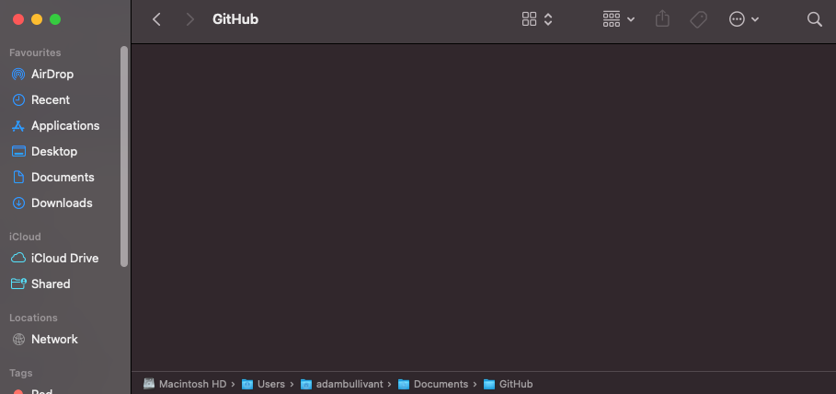

Now, open a terminal window and ensure your current directory is the folder you want the repo to be stored. For example:

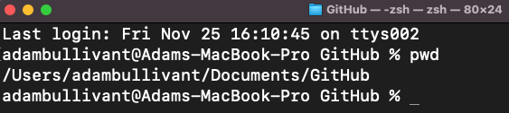

Inside the terminal, type ‘git clone’ and then paste the previously copied MOP-Code repo link like below:

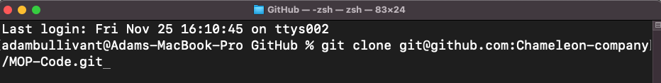

Execute the command (press enter) and wait for the repository to be cloned onto your local machine. This process can take some time so just wait until you receive the following display on your terminal:

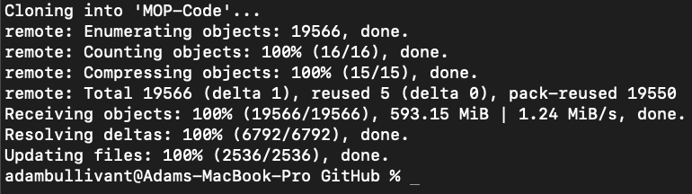

When you open the directory you wanted to put the repository in now, a new folder ‘MOP-Code’ should appear, and inside this should hold all of the files and folders like below:

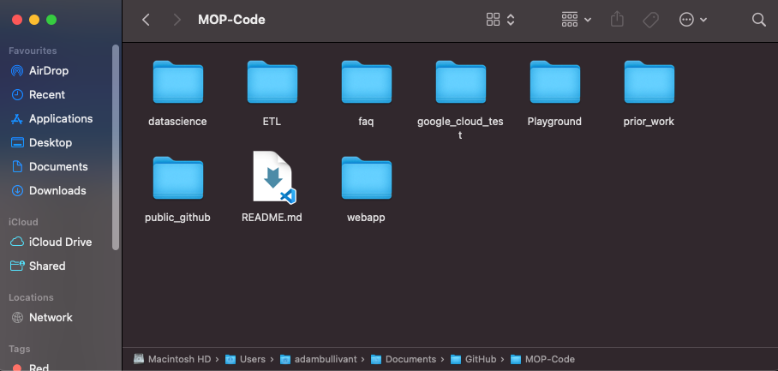

# 3. Installing Miniconda

Install Miniconda [here](https://docs.conda.io/en/latest/miniconda.html). Once completed, there should be a folder on your computer like follows:



# 4. Install and Setup Anaconda

Now we must install Anaconda [here](https://www.anaconda.com/products/distribution). This will allow us to set up a ‘MelbourneCityOpenData’ environment with all required packages to run the use cases. Once Anaconda has been downloaded, open it and you should see the following screen:

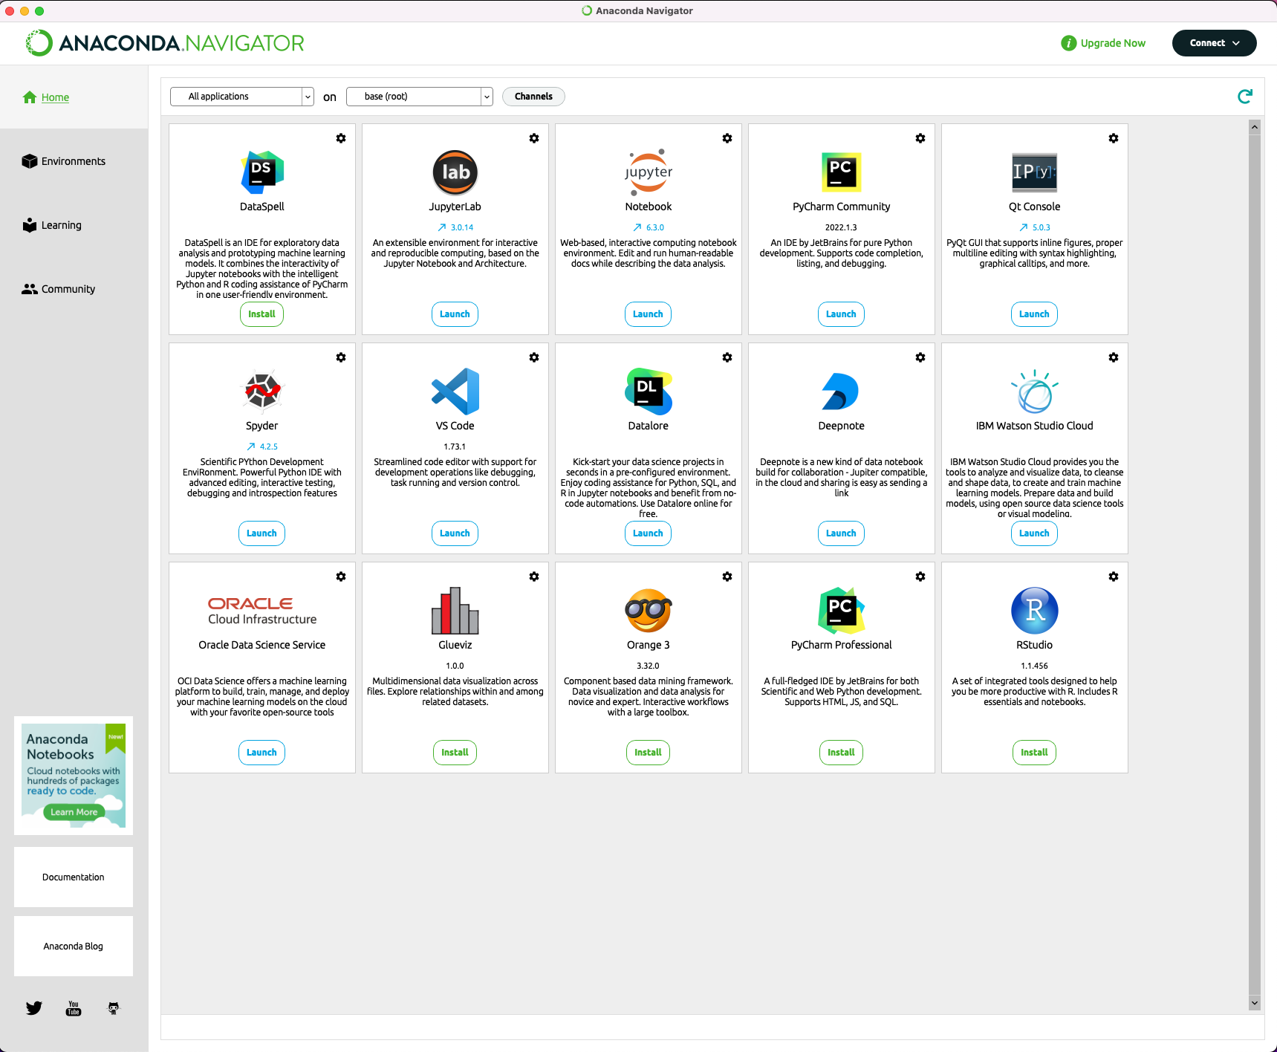

Now, to setup the environment, ensure you’re currently on the “base(root)” environment like below:

Once you have this environment selected, open a new terminal, and change the directory to where the ‘environment.yml’ file is located. With respect to the repo, it can be found through:

MOP-Code/datascience/condaconfiguration/

For example, on our terminal currently, the file is located like below:

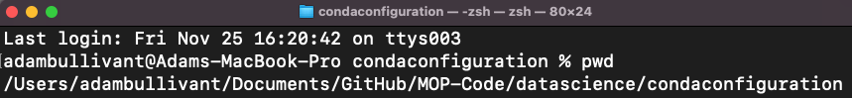

Now, once inside this folder, execute the following command ‘conda env create -f environment.yml’ like below:



The terminal should display ‘solving environment’ and eventually reach done. All installations of packages are then executed, and your terminal should look like below. This may take some time to complete so just wait for the command to be done.

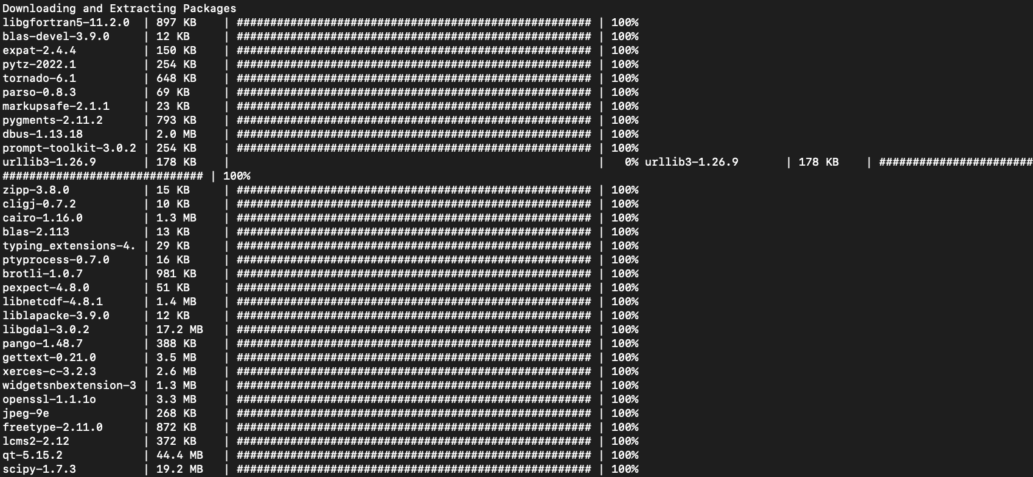

When completed, your terminal should display the following:

Now we simply execute ‘conda activate MelbourneCityOpenData’ to activate the environment. Now if we go back into Anaconda, we should be able to see an environment labelled ‘MelbourneCityOpenData’ like below:

Select this and now you will be able to open and run Jupyter Notebooks with the required packages for the Data Science team. This means you can execute all previous use cases.

# 5. Opening Notebooks of Use Cases

Launch a Jupyter Notebook from Anaconda (make sure the MelbourneCityOpenData environment is selected). Your browser should open and show something like the following:

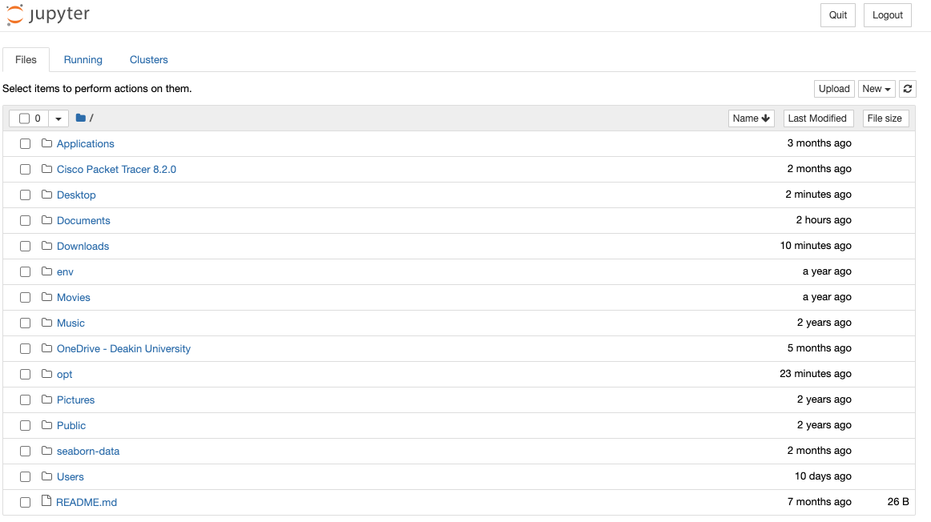

Now find the directory of where we initially cloned the MOP-Code repository. In this example, it was under Documents/GitHub. Open this and you should see all of the folders and files of the repo:

Go into datascience/usecases and you should see all of the notebooks of existing use cases:

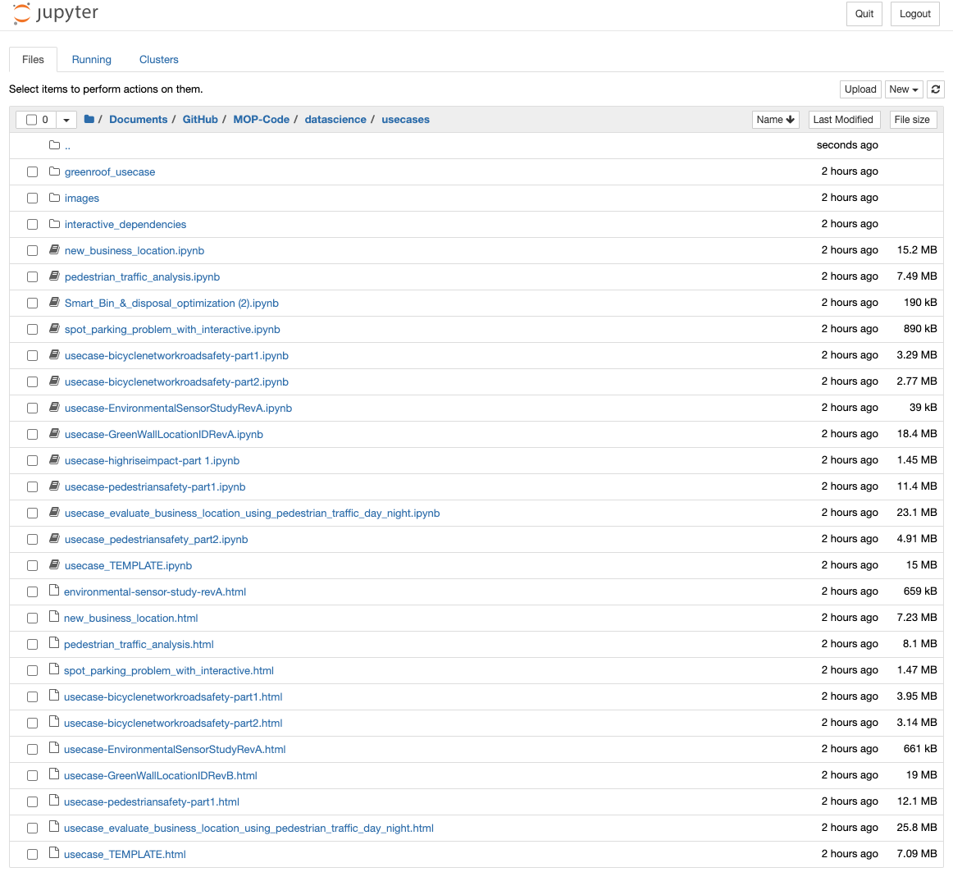

You now should be able to open these and run them successfully as we are using the MelbourneCityOpenData environment that has all of the required packages.

Follow the remainder of the Onboarding Checklist for Upskilling on Git Commands and how you can begin adding your own use cases to your local repo and eventually merging them into the official MOP-Code repository!

## Author

Adam Bullivant (version 1, T3 2022)